**Product Price Classification**

**Course: NLP (Semester 6) - Pillai College of Engineering**

**Project Overview :**

This project focuses on classifying products into predefined price ranges—Low, Medium, and High—using Natural Language Processing (NLP) and Machine Learning (ML). Instead of relying on direct price data, the system analyzes product descriptions to predict price categories. By leveraging advanced NLP techniques and various ML models, this project aims to enhance product search and price-based decision-making for e-commerce platforms. Traditional price categorization relies on direct price data, which can be inconsistent due to discounts and currency variations. This system introduces a text-based classification approach, making product categorization more scalable and flexible. It benefits both consumers and retailers by improving search filtering, optimizing pricing strategies, and automating classification to reduce manual effort.

You can learn more about the college by visiting the official website of [Pillai College of Engineering.](https://www.pce.ac.in/)

**Acknowledgements:**

We would like to express our sincere gratitude to the following individuals:

**Theory Faculty:**

* Dhiraj Amin
* Sharvari Govilkar

**Lab Faculty:**

* Dhiraj Amin
* Neha Ashok
* Shubhangi Chavan

Their guidance and support have been invaluable throughout this project.

**Project Title :**

Product Price Classification

**Project Abstract:**

This project classifies products into Low, Medium, and High price categories using NLP and machine learning. It extracts insights from product descriptions and applies classification algorithms to predict price ranges. By utilizing ML, deep learning models, and advanced language models, the project evaluates various approaches for accuracy and effectiveness. Text preprocessing techniques like tokenization and word embeddings convert product descriptions into numerical representations. Models such as Logistic Regression, SVM, Random Forest, CNN, RNN, LSTM, and BERT are tested to determine the most effective classification method. This system automates price categorization, benefiting e-commerce platforms by improving product organization, aiding marketing strategies, and enhancing consumer insights.

**Algorithms Used:**

**Machine Learning Algorithms:**

* Logistic Regression
* Support Vector Machine (SVM)
* Random Forest Classifier

**Deep Learning Algorithms:**

* Convolutional Neural Networks (CNN)
* Recurrent Neural Networks (RNN)
* Long Short-Term Memory (LSTM)

**Language Models:**

* GPT
* BERT (Bidirectional Encoder Representations from Transformers)

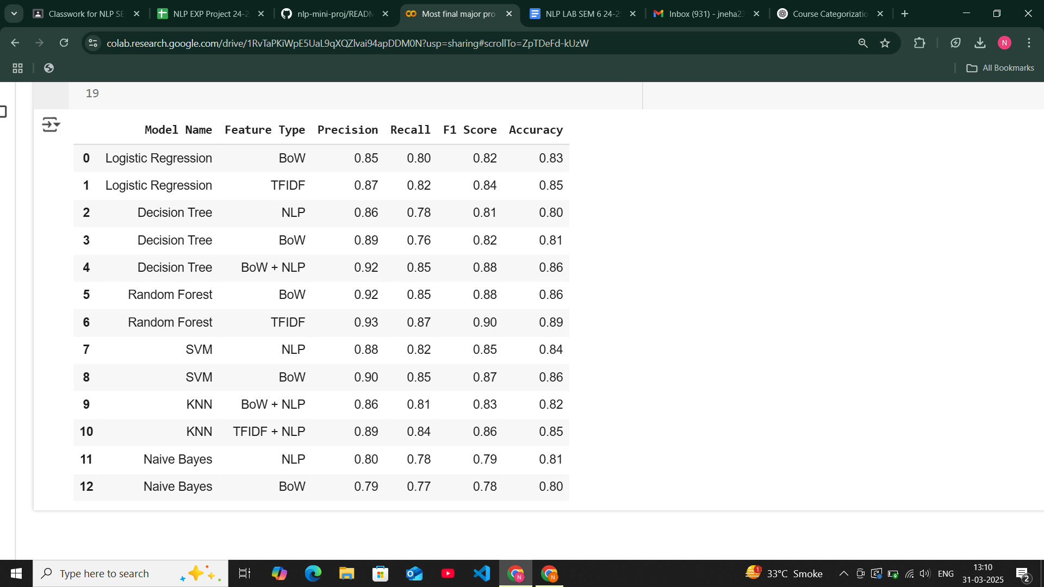

**Conclusion :**

This project highlights the effectiveness of NLP and ML models in product price classification. The analysis shows that BERT outperforms other models in accuracy and precision. By automating price-based categorization, this system improves product search, pricing strategies, and consumer insights for e-commerce platforms.